LITTLE TWINS JULY SALES SQL QUERIES

- KPI’s:
- Total Revenue:
SELECT
SUM(Net_Sales) AS Total_Revenue
FROM LittleTwins_July_Sales;

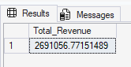

- Average Order Value:
SELECT
SUM(Net_Sales) / COUNT(DISTINCT
Transcation_ID) AS Average_Value
FROM LittleTwins_July_Sales;

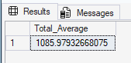

- Total Quantity Sold:
SELECT
SUM(Quantity) AS Total_Product_Sold
FROM LittleTwins_July_Sales;

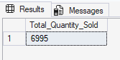

- Total Transactions:

SELECT
COUNT(DISTINCT Transcation_ID) AS Total_Transcation
FROM LittleTwins_July_Sales;

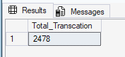

- Average Item Per Transaction:

SELECT
CAST(SUM(Quantity) AS decimal(10,2)) /
CAST(COUNT(DISTINCT Transcation_ID)
AS decimal (10,2)) AS Avg_item_Transcation
FROM LittleTwins_July_Sales;

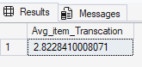

CHARTS REQUIREMENTS:

- Daily Trend For Total Transaction:
SELECT
CAST(Transaction_Date AS DATE) AS Transaction_day,
COUNT(DISTINCT Transcation_ID) AS Total_Transactions
FROM LittleTwins_July_Sales
GROUP BY CAST(Transaction_Date AS DATE)
ORDER BY Transaction_day;

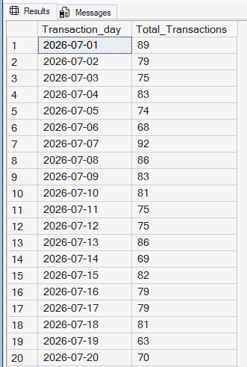
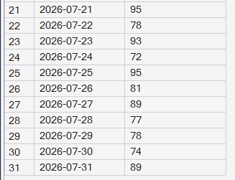

- Hourly Trend For Total Transaction:
SELECT
DATEPART(HOUR, Transaction_Time) AS Transaction_Hours,
COUNT(DISTINCT Transcation_ID) AS Total_Transactions
FROM LittleTwins_July_Sales
GROUP BY DATEPART(HOUR, Transaction_Time)
ORDER BY Transaction_Hours;

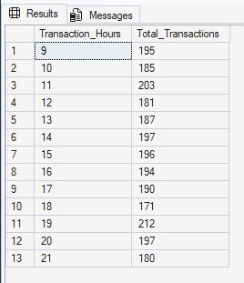
- Percentage of Sales by Product Category:
SELECT
Category,
ROUND(
SUM(Net_Sales) * 100 /
( SELECT SUM(Net_Sales)
FROM LittleTwins_July_Sales), 2
) AS Percentage_of_Sales
FROM LittleTwins_July_Sales
GROUP BY Category
ORDER BY Percentage_of_Sales DESC;

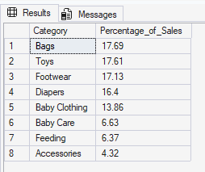

- Percentage of sale by Payment Mode:

SELECT
Payment_Mode,
ROUND(
SUM(Net_Sales) * 100.0 /
( SELECT SUM(Net_Sales)
FROM LittleTwins_July_Sales), 2
) AS Percentage_of_Payment
FROM LittleTwins_July_Sales
GROUP BY Payment_Mode
ORDER BY Percentage_of_Payment DESC;

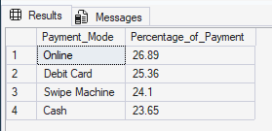

- Total Quantity Sold by Product Category:

SELECT
Category,
SUM(Quantity) AS Total_Quantity
FROM LittleTwins_July_Sales
GROUP BY Category;

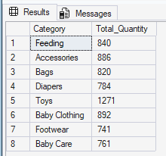

- Top 5 Best Sellers by Quantity Sold:

SELECT TOP 5
Product,
SUM(Quantity) AS Total_Quantity_Sold
FROM LittleTwins_July_Sales
GROUP BY Product
ORDER BY Total_Quantity_Sold DESC, Product ASC;

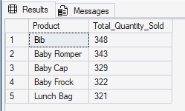

- Bottom 5 Worst Sellers by Quantity Sold:

SELECT TOP 5
Product,
SUM(Quantity) AS Total_Quantity_Sold
FROM LittleTwins_July_Sales
GROUP BY Product
ORDER BY Total_Quantity_Sold ASC, Product ASC;

